Sphincter of Oddi Dysfunction Presenting After Gallbladder Surgery

A 38-year-old female, mother of two children, had right upper quadrant abdominal pain with shoulder radiation severe enough to require an emergency room trip. Gallstones were detected by ultrasound (Figure 1) which showed multiple shadowing stones in the gallbladder. Laparoscopic (telescopic) gallbladder removal was done. An intraoperative cholangiogram was normal. She was well for the next two years. Gradually, right upper abdominal pain returned. The pain was nearly identical to the prior pain. There was associated nausea but no vomiting. She intermittently missed work due to the pain. There was no fever, chills, weight loss, or diarrhea. Thorough re-evaluation with ultrasound, CT scan, UGI endoscopy, and blood tests for evaluation of liver, pancreas, anemia, or infectious problems were all normal except one liver blood test (alkaline phosphate) was minimally elevated. The bile duct diameter was 8 mm. Trials of antispasmodic medications and pain relievers such as Darvon helped to partially control the pain.
After six months of persistent symptoms and missing work a few more days, a Gastroenterology referral was made. An MRCP was done which showed normal bile ducts and pancreatic ducts (Figure 2). An ERCP with pressure testing (manometry of the Sphincter of Oddi) was done after detailed discussion. The contrast media (iodine dye) injection confirmed normal ducts (no stones, tumors, or strictures present) and normal pancreatogram (No stones, rumors, or chronic pancreatitis) (Figures 3). Biliary manometry (Figure 4a) showed an abnormal biliary sphincter basal pressure at 85 mmHg. Pancreatic manometry done with an aspiration type catheter (the safest technique) also showed abnormal basal pressure at 60 mmHg (Figure 4b). (All basal sphincter pressures greater than 40 mmHg are too high). A combined pancreatabiliary sphincterotomy was done and temporary small caliber pancreatic stent was placed (the stent is for decreasing potential pancreatitis after ERCP) (Figure 5). Her typical pain resolved in three days.
A plain abdominal x-ray in two weeks confirmed that the protective stent had exited of the pancreas and passed in a bowel movement (Figure 6). She has remained without abdominal symptoms for the subsequent three years.
Comments: Sphincter of Oddi dysfunction is the most common cause of recurrent pain after gallbladder surgery. Other causes are bile duct stones, chronic pancreatitis, irritable bowel syndrome and, rarely, tumors of the pancreas or bile ducts. Note that both the bile duct and pancreas portions of the sphincter were abnormal. This occurs in 2/3 of patients. Biliary sphincterotomy alone will be adequate treatment in only half of such cases.

Figure (1) : US image showing gall bladder stones
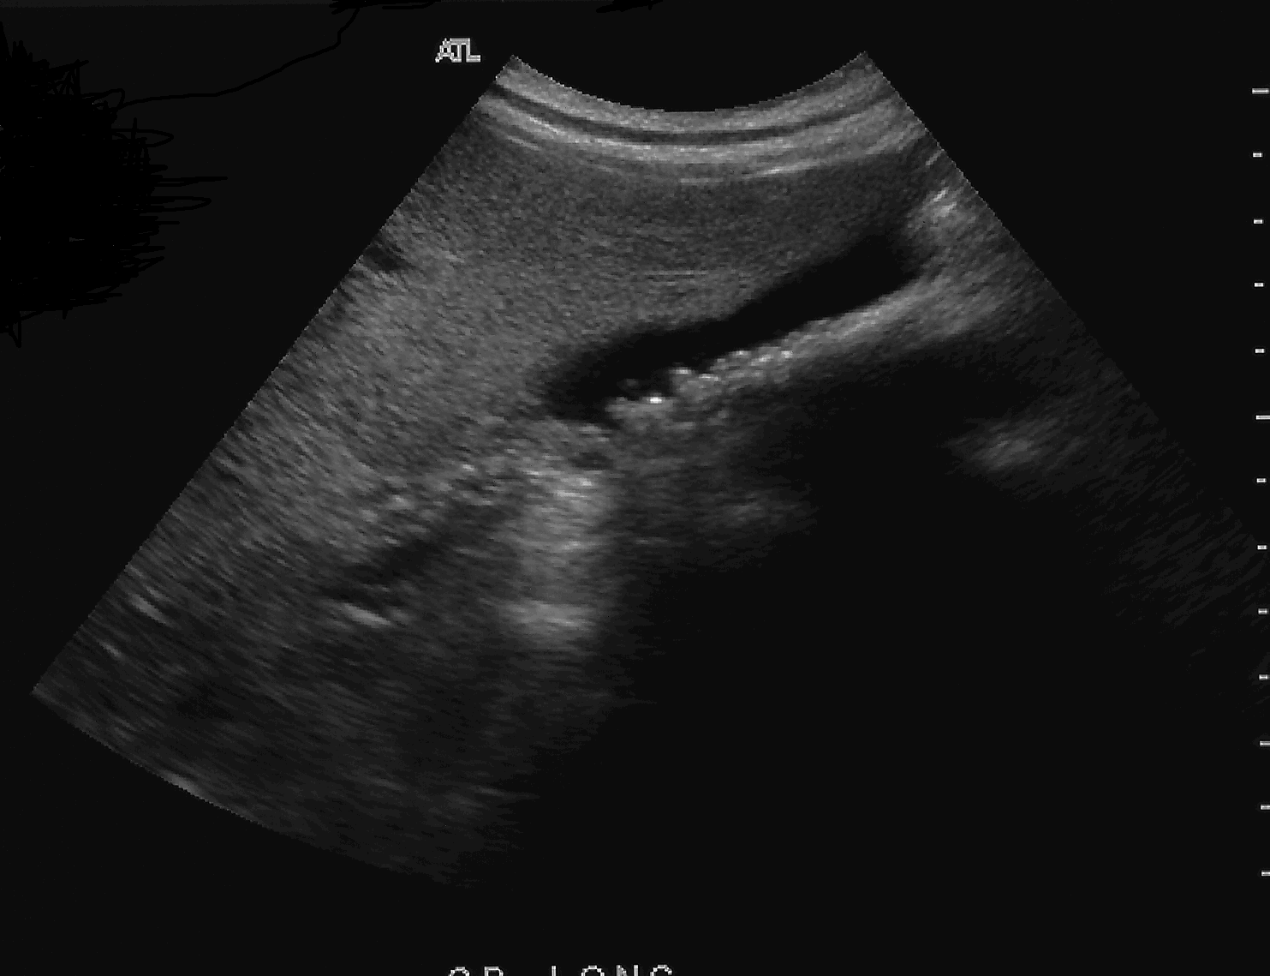

Figure (2): Normal MRCP after cholecystectomy
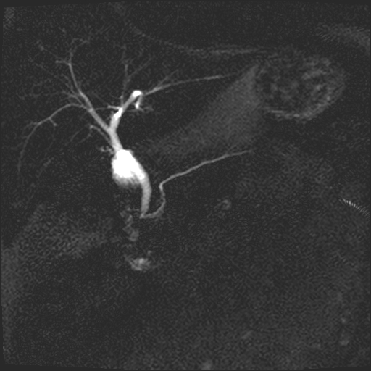

Figure (3): Normal cholangiogram and pancreatogram at ERCP
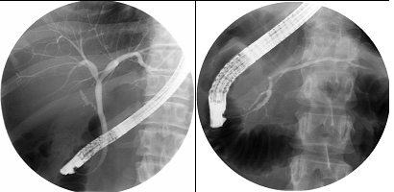

Figure (4 a&b): Manometry showing abnormal biliary (a) and pancreatic (b) sphincter prtessures
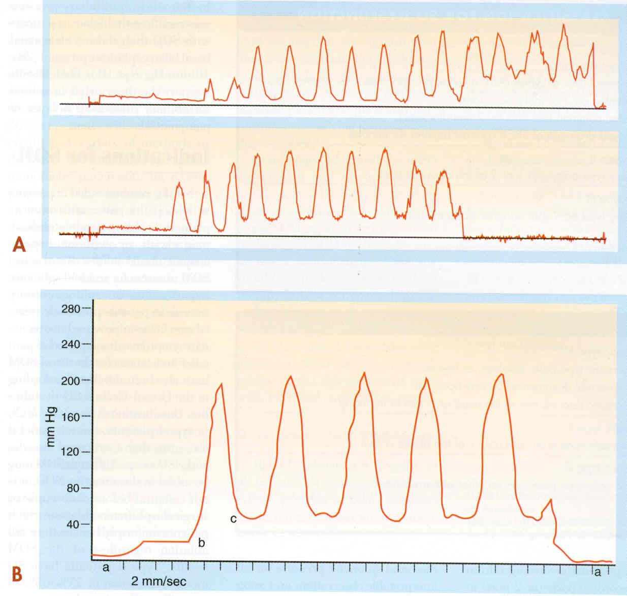

Figure (5): Prophylactic pancreatic stent
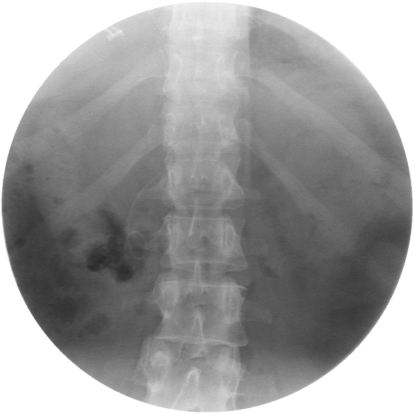

Figure (6): KUB after 2 weeks showing spontaneous dislodgement of the prophylactic pancreatic stent.

